Current Academic Year _________________________ (what 6 encounters have you planned this year and when)
 | Term 1 | Term 2 | Term 3 | Term 4 | Term 5 | Term 6
Year 8
Year 9 |  |  |  | Deadline is end February
Year 10
Year 11 |  |  |  | Deadline is end February
Year 12

Year 13 |  |  |  | Deadline is end February

Tracking the Phases as they move through the school (what 2 encounters per phase has each cohort had?)
Started  Year 7  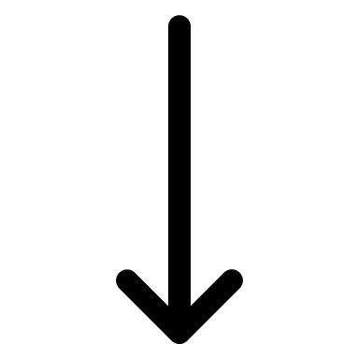 | Year 8 – Year 9  (Sept to Feb) | Year 10 – Year 11  (Sept to Feb) | Year 12 – Year 13  (Sept to Feb)
Cohort  2022 | 1.  2. | 1.  2. | 1.  2.
Cohort  2023 | 1.  2. | 1.  2. | 1.  2.
Cohort  2024 | 1.  2. | 1.  2. | 1.  2.
Cohort  2025 | 1.  2. | 1.  2. | 1.  2.
Cohort  2026 | 1.  2. | 1.  2. | 1.  2.
Cohort  2027 | 1.  2. | 1.  2. | 1.  2.
Cohort  2028 | 1.  2. | 1.  2. | 1.  2.

